# Lab Completion Form

## Lab 1: Testing Network Connectivity with Ping and Traceroute

Instructions:  
Refer to the attached PDF (lab2-ping-traceroute.pdf).

### Answer the following questions:

1. What is the purpose of the Ping command?

- Answer: [To troubleshoot network connectivity]

2. What command did you use to trace the route to a website?

- Answer: [Tracert]

### Screenshot:

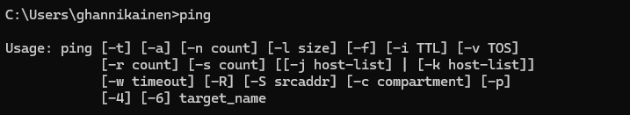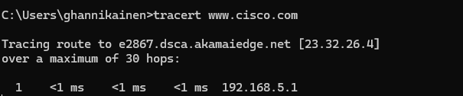

Attach a screenshot of the output of the Ping and Traceroute commands.  
 - Answer: []

## Lab 2: Viewing Host Routing Tables

Instructions:  
Refer to the attached PDF (lab2-host-routing-tables.pdf).

### Answer the following questions:

1. What is the purpose of a routing table?

- Answer: [To determine the best path]

2. What command did you use to view the routing table?

- Answer: [netstat -r]

### Screenshot:

Attach a screenshot of your routing table output.  
 - Answer: [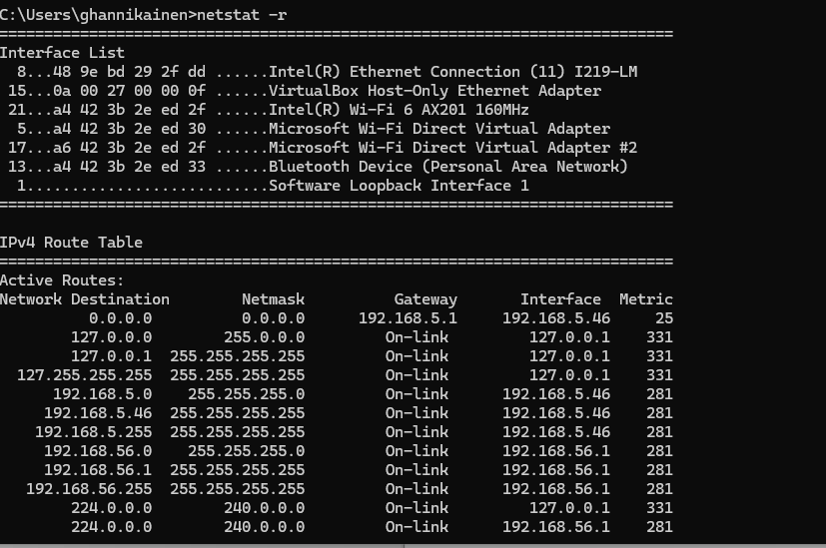]

## Lab 3: Observing DNS Resolution

Instructions:  
Refer to the attached PDF (lab2-dns-resolution.pdf).

### Answer the following questions:

1. What IP address did DNS resolve for www.google.com?

- Answer: [216.58.211.228]

2. What command did you use to look up the IP address of a website?

 - Answer: [nslookup]

### Screenshot:

Attach a screenshot of your DNS lookup using the nslookup command.  
 - Answer: []

## Lab 4: Viewing NIC Information

Instructions:  
Refer to the attached PDF (lab2-nic-information.pdf).

### Answer the following questions:

1. What is the MAC address of your wired NIC?

- Answer: [48-9E-BD-29-2F-DD]

2. What command did you use to view the NIC information?

- Answer: [ipconfig /all]

### Screenshot:

Attach a screenshot of your NIC information.  
 - Answer: [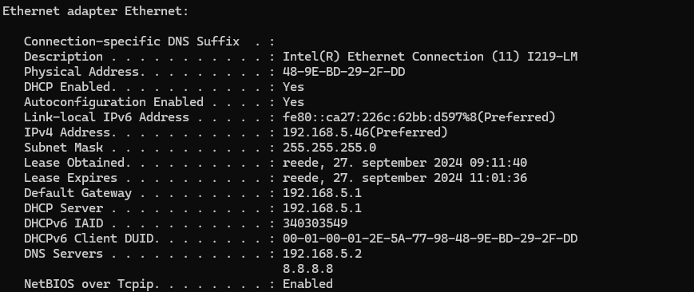]

## Lab 5: Using Wireshark to Capture Network Traffic

Instructions:  
Refer to the attached PDF (lab2-wireshark-traffic.pdf).

### Answer the following questions:

1. What IP address was captured during the ping to www.google.com?

- Answer: [ 216.58.211.228]

2. What tool did you use to capture network traffic?

- Answer: [nslookup/ping both gave me the same results]

### Screenshot:

Attach a screenshot of your Wireshark capture showing ICMP traffic.  
 - Answer: [